UART USING SV

OBJECTIVE
- Clearly articulate the definition, function, and module division of UART to provide a comprehensive understanding of its role in communication systems.
- Instruct students on building UART using System Verilog emphasizing a detailed simulation process.

TOOLS
• Xilinx Vivado
UNIVERSAL ASYNCHRONOUS RECEIVER TRANSMITTER

INTRODUCTION
UART is a serial communication protocol that transmits data asynchronously, meaning it does not require a shared clock signal between the transmitter and receiver. Unlike parallel systems, UART reduces the number of wires and I/O pins needed, though at a lower speed. Data is sent serially, one bit at a time, framed by start and stop bits.

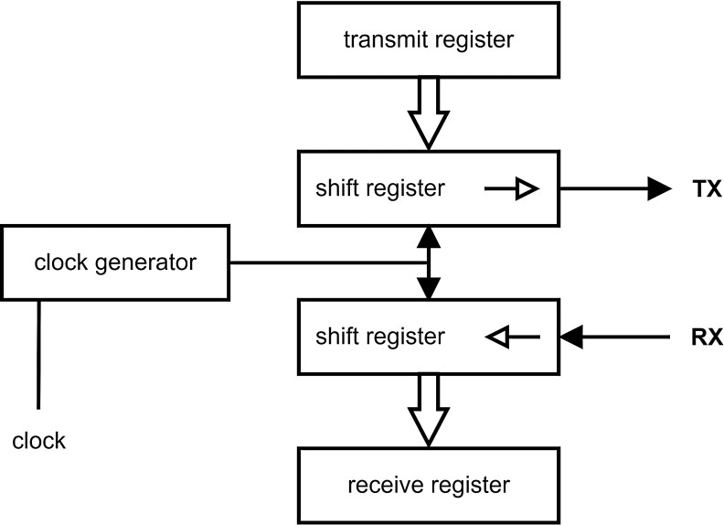
Fig 1: Block Diagram of UART

Key elements for successful UART communication include:
- Baud Rate: Speed of transmission in bits per second (bps); common default is 9600 bps. Transmitter and receiver must use the same baud rate.
- Data Bits & Endian-ness: Data is typically 8 bits per packet. Big-endian sends the most significant bit first; little-endian sends the least significant bit first.
- Synchronization Bits: Start and stop bits mark the beginning and end of a data packet. A high line indicates idle, a low-to-high transition marks start and stop.
- Parity Bits: Optional error-checking method. Parity bits indicate whether the number of 1s in the data is even or odd, helping detect transmission errors.

UART’s simplicity and asynchronous operation make it widely used in embedded systems and microcontroller communication.

Top level diagram

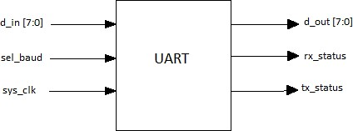
Fig 2: Top level diagram of UART.

Pins | Width | I/O | Description
D_IN | 8 bits | Input | Input data from data bus.
SEL_BAUD | 2 bits | Input | Used to select different baud set for different values of pin.
SYS_CLK | 1 bit | Input | Input clock to UART from FPGA board on which it runs.
D_OUT | 8 bits | Output | Output data sent to data bus.
RX_STATUS | 1 bit | Output | Shows status of receiver.
TX_STATUS | 1 bit | Output | Shows status of transmitter.

Table 1: Pin description for top level diagram of UART.

Architecture
UART architecture consists of three main blocks Transmitter, Receiver and Baud rate generator. The data is taken from the computer or the peripheral devices. Below are the block level micro-architecture and working of the modules.

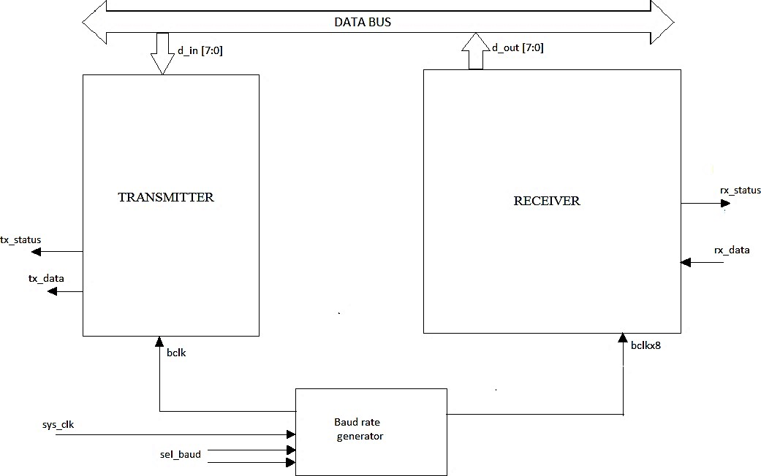

Fig 3: Architecture of UART

Transmitter Module
Block level micro-architecture of transmitter module is given below,

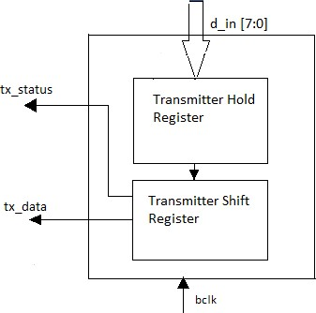
Fig 4: Micro-architecture of transmitter module.

All the operations in transmitter are with respect to clock which runs on multiple baud rates. The transmitter converts the 8-bit parallel data into serial data and adds start bit at start of the data frame and stop bit at the end of the data frame.

Receiver Module
Block level micro-architecture of receiver module is given below,

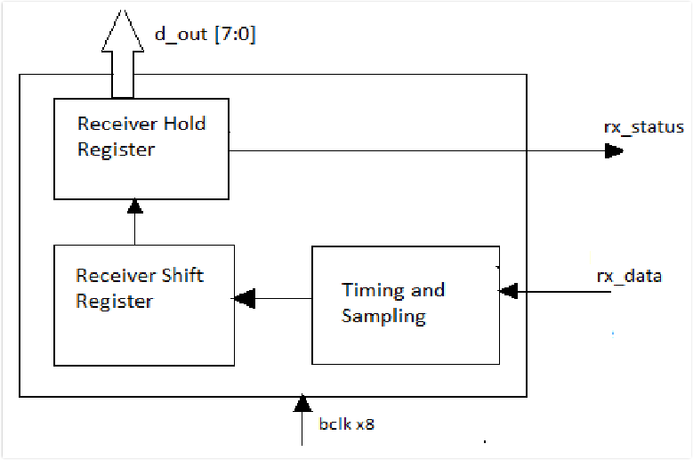
Fig. 6 Micro-architecture of receiver module.

All operations in the receiver are synchronized with a clock running at the selected baud rate. The receiver detects the start bit, reads the incoming serial data bit by bit, and reconstructs it into 8-bit parallel data. Finally, it verifies the stop bit to ensure the data frame is correctly received.

Baud rate Generator Module and oversampling
Block level micro-architecture of baud rate generator is given below,

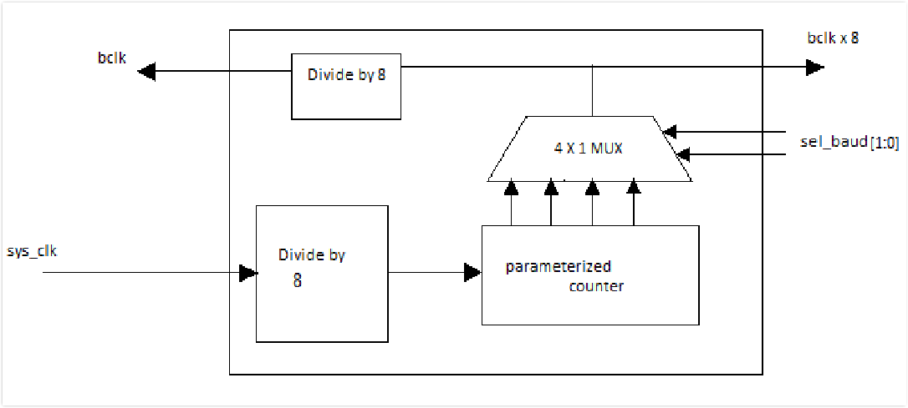
Fig 8: Micro-architecture of baud rate generator.

The baud rate generator divides the system clock to produce the required baud rates for UART communication. In this project, the FPGA provides a 100 MHz system clock, which is first divided by 8 using a clock divider to synchronize data bits on the positive clock edge. A parameterized counter then counts the divided clock cycles, and its output is further divided according to the required baud rate using the formula: Divisor = sys. Clock / (8 × baud rate). A 4×1 multiplexer selects the desired baud rate based on the select lines, and its output is fed to both the transmitter and receiver. The transmitter uses the clock after the divide-by-8 block, while the receiver uses the multiplexer output directly, resulting in the receiver clock being eight times faster than the transmitter clock.
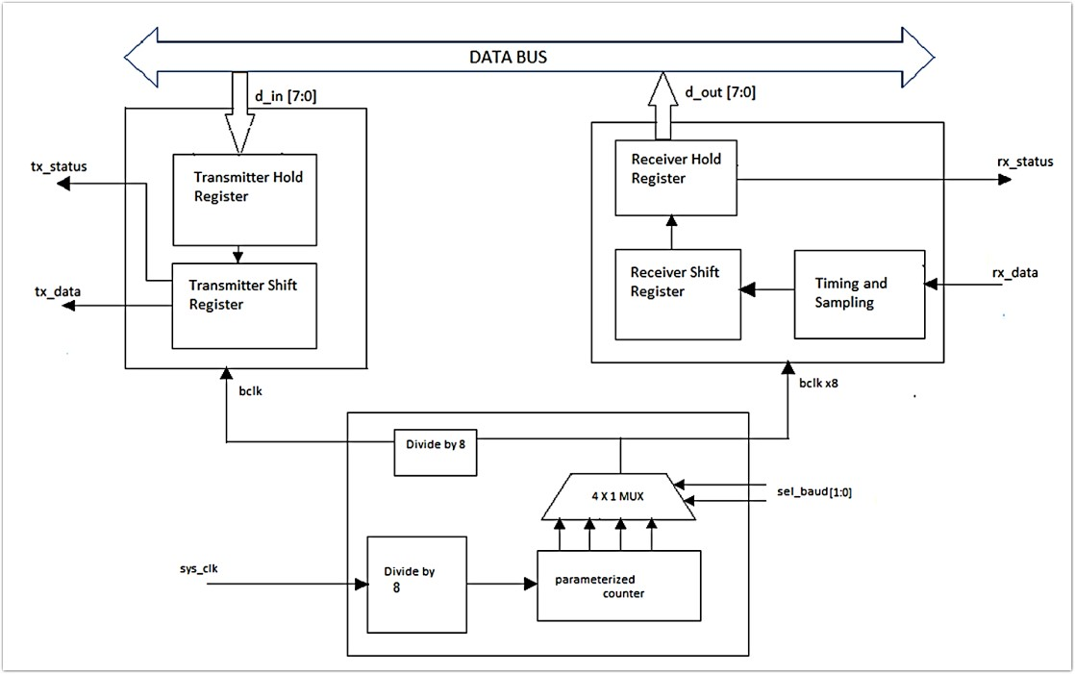

Fig 8: Micro-architecture UART.

The diagram illustrates a UART communication system with both transmitter and receiver modules connected via a data bus. The transmitter consists of a Transmitter Hold Register and a Transmitter Shift Register, which take 8-bit parallel input (d_in[7:0]) and serialize it for transmission using the bclk clock. The receiver contains a Receiver Shift Register, Receiver Hold Register, and a Timing and Sampling block to deserialize incoming serial data and produce 8-bit parallel output (d_out[7:0]). A baud rate generator produces the required clocks for both modules: the system clock (sys_clk) is divided and fed to a parameterized counter, whose output is selected via a 4×1 multiplexer (sel_baud[1:0]) to generate different baud rates. The transmitter uses the divided clock (bclk) while the receiver uses a clock that is eight times faster (bclk × 8) to ensure proper sampling of the incoming data, maintaining synchronized and reliable serial communication.

LAB TASK
Design a full-duplex UART protocol using System Verilog. Verify your test cases by writing testbench.
Specifications:
Following are the specification extracted and implemented.
- Mode: Full Duplex.
- Data Frame Sequence: 8 bits
- Primary Frequency: 100MHz
- 1 start bit, 1 stop bit. No parity bit.
- No. of flags: 2.

RECEIVER STATE TRANSITION DIAGRAM
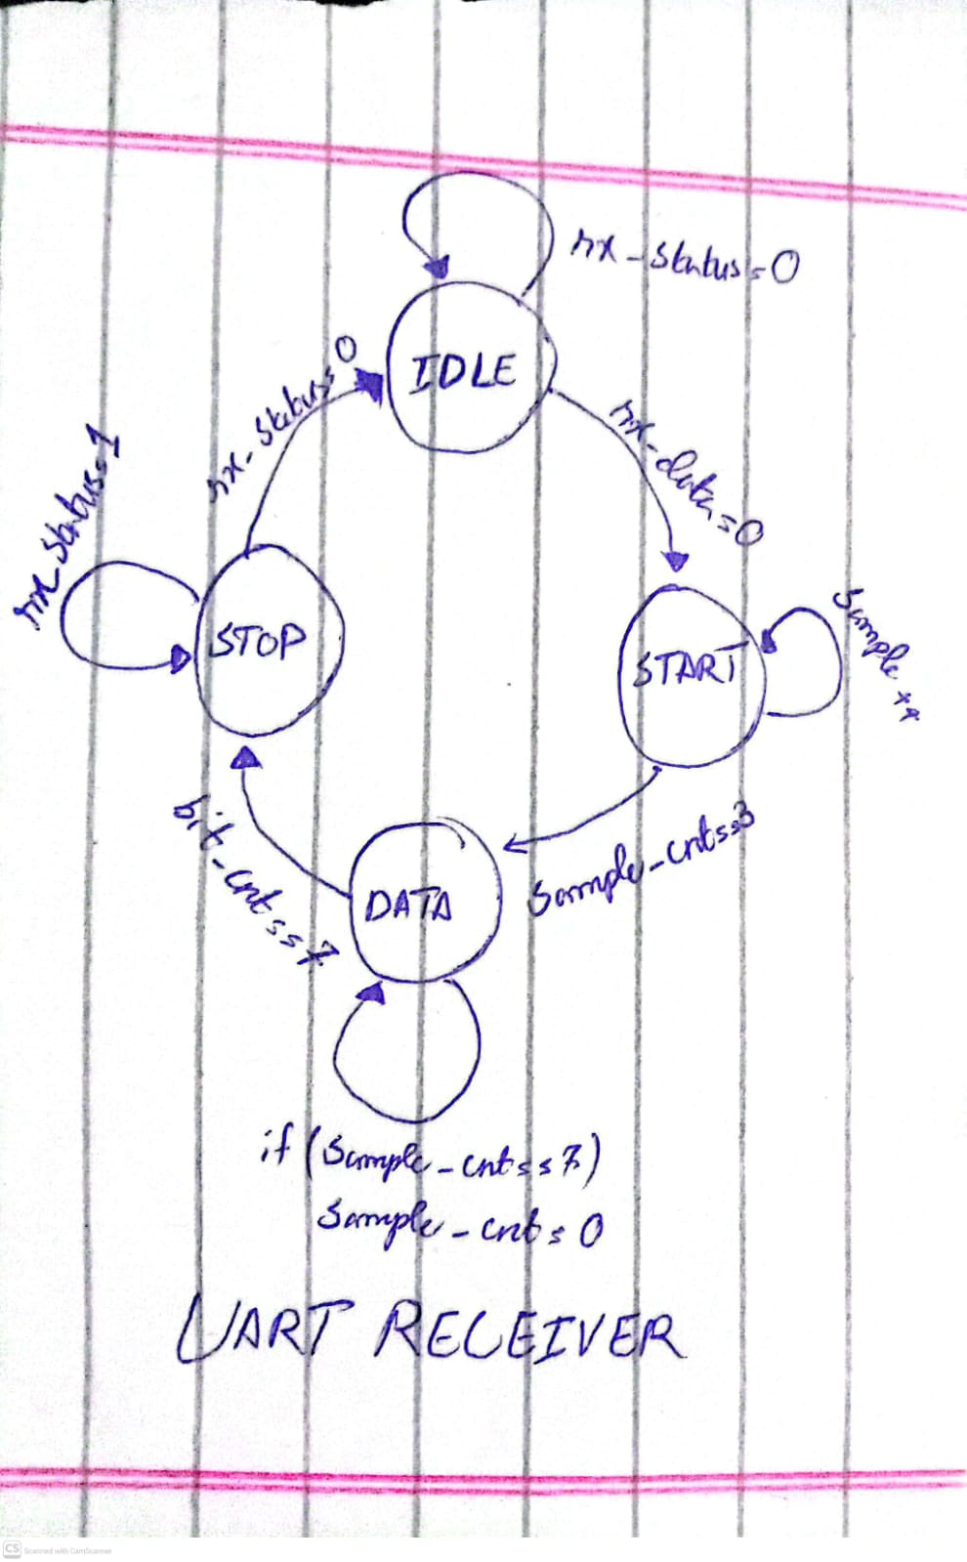

The diagram represents the state transition of a UART receiver. It shows four main states: IDLE, START, DATA, and STOP.
- IDLE: The receiver waits for incoming data; rx_status = 0. When a start bit is detected (rx_data = 0), it transitions to the START state.
- START: The receiver samples the start bit and initializes the sample counter. Once the start bit is confirmed, it moves to the DATA state.
- DATA: In this state, the receiver sequentially samples each data bit, incrementing the bit counter. Once all data bits are received (bit_cnt = 7), the state transitions to STOP.
- STOP: The receiver checks the stop bit to ensure the data frame is correctly received. After verification, it returns to IDLE (rx_status = 0) to wait for the next data frame.
The diagram also indicates that the sample counter resets when needed, ensuring precise timing for asynchronous data reception. This state machine ensures reliable detection and reconstruction of serial data into parallel form.

TRANSMITTER STATE TRANSITION DIAGRAM
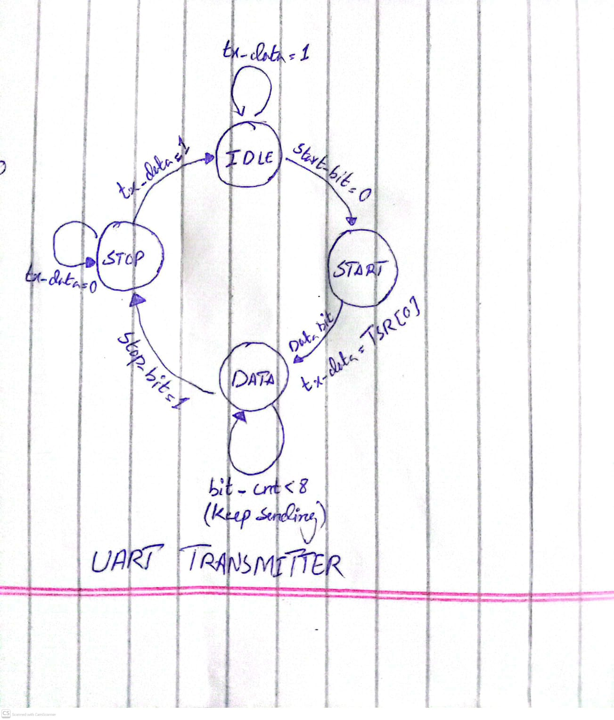

- The UART Transmitter state machine works in a cyclic process: IDLE → START → DATA → STOP → IDLE, which repeats for each byte of data.
- The UART Transmitter state machine ensures correct UART transmission with proper timing of start, data, and stop bits.
- The tx_data and bit_cnt signals control the flow and sequencing of bits, while the start_bit and stop_bit signals define the UART framing.
This UART transmitter state diagram shows the sequence of states for sending serial data:
- IDLE: Default state; waits for a start bit (start_bit = 0).
- START: Sends the start bit (0) and moves to DATA.
- DATA: Sends 8 data bits one by one (tx_data = TSR[0]); loops until all bits are sent.
- STOP: Sends the stop bit (1) and returns to IDLE.
The process repeats for each byte, ensuring proper UART transmission with start, data, and stop bits.

TOP LEVEL OUTPUT
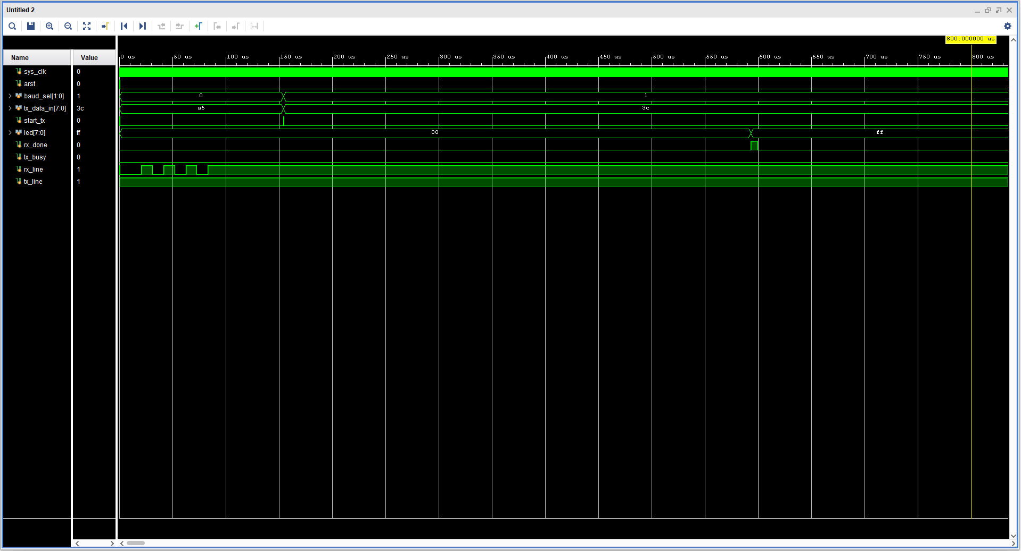

ELABORATED DESIGN
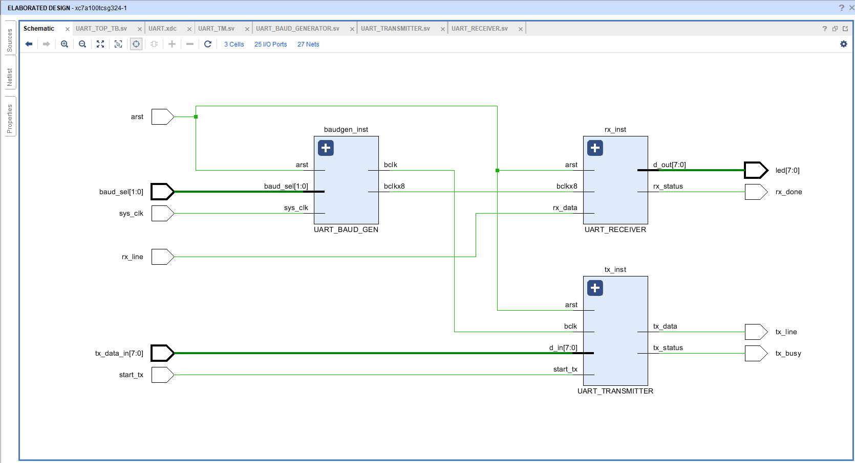

SYNTHSIZED DESIGN
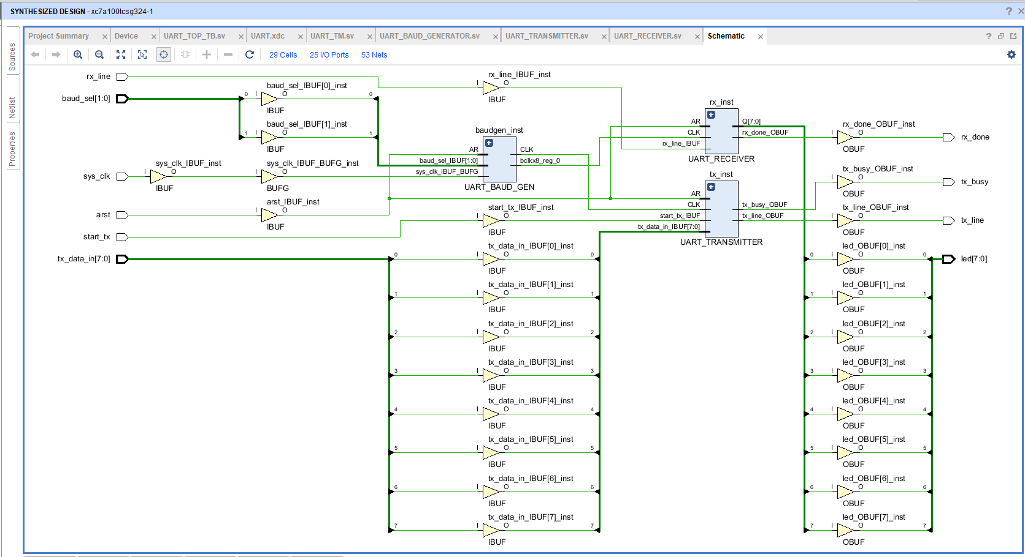

TERA TERM CONSOLE OUTPUT

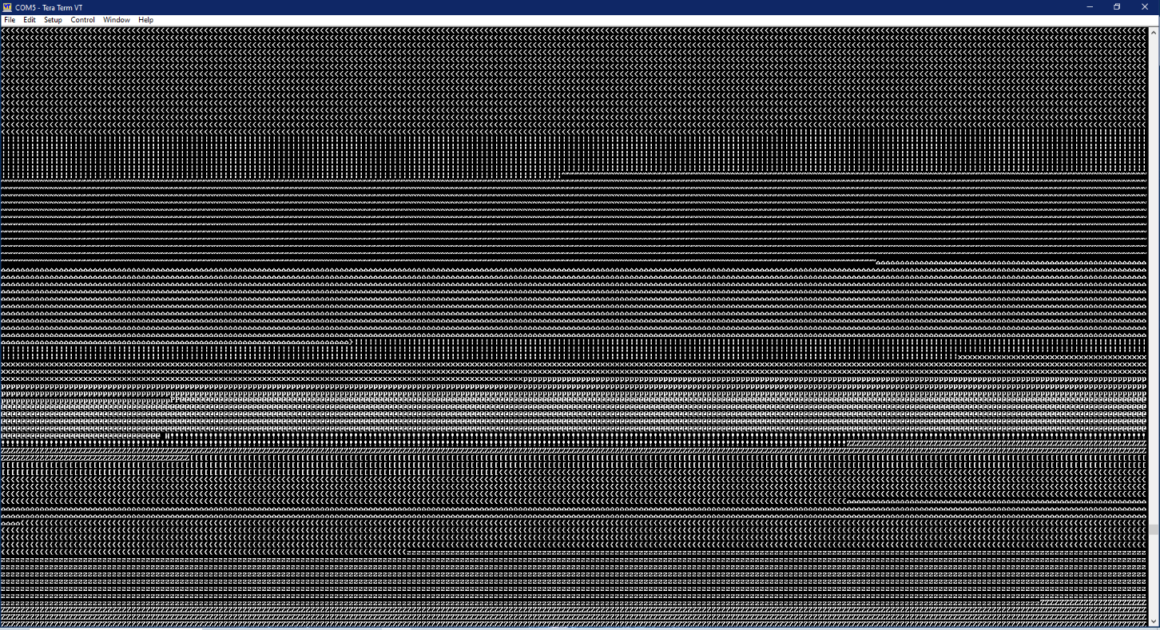
TRANSMISSION FROM FPGA
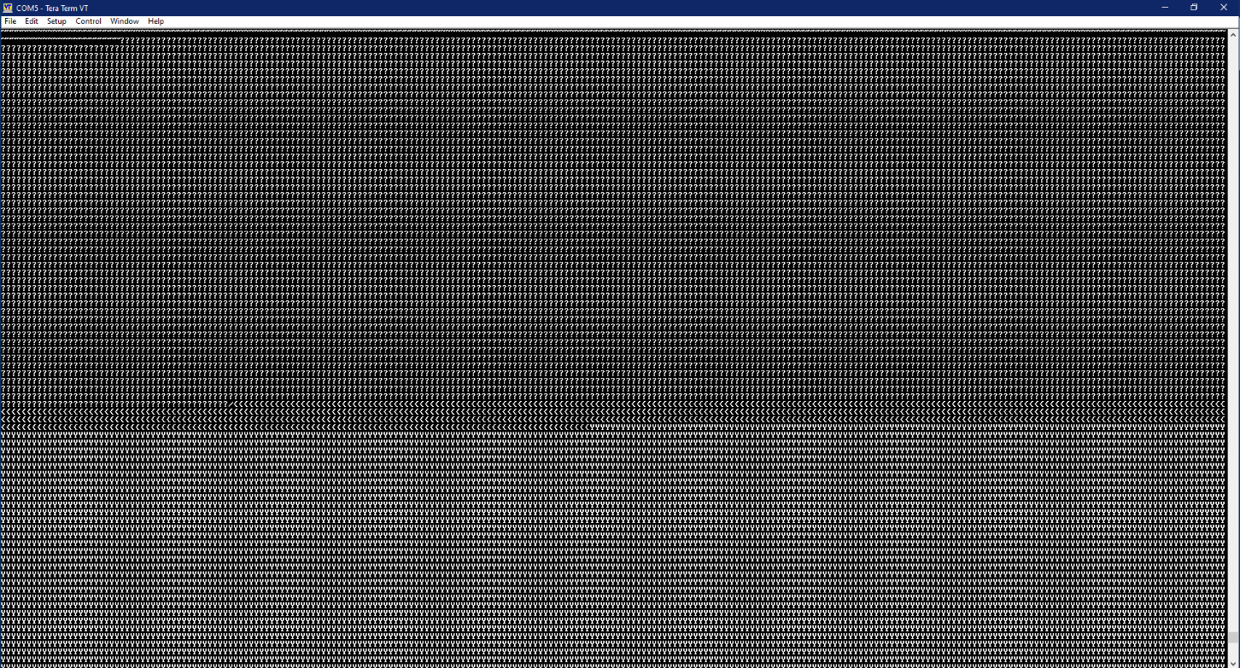

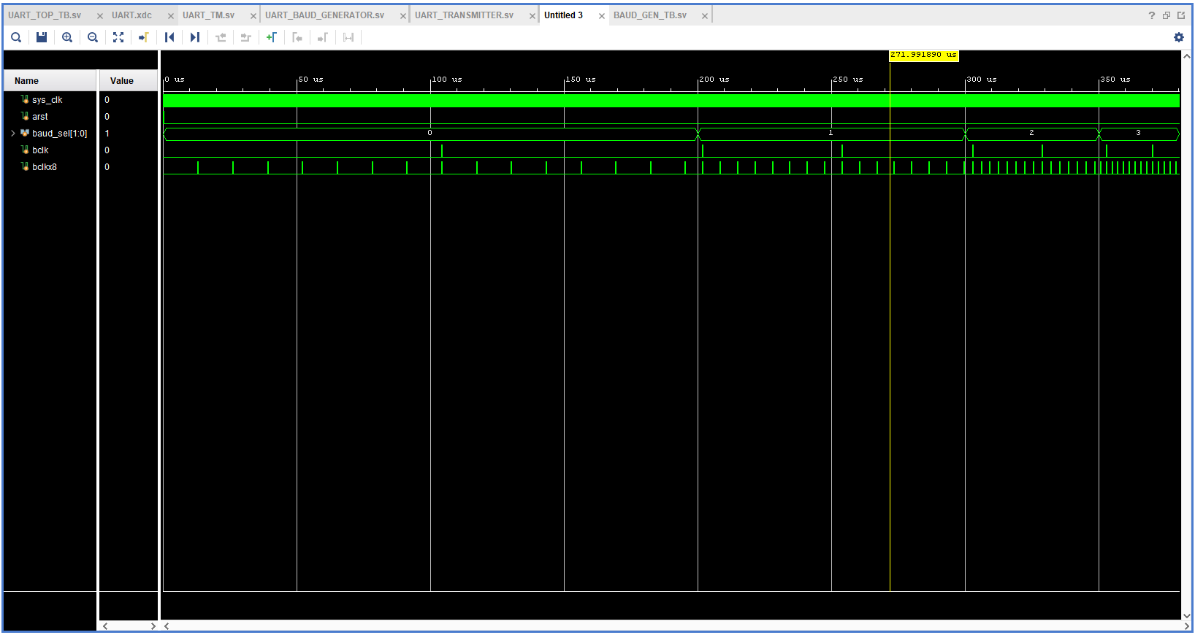

BAUD GENERATOR
On behalf of baud_sel the generator will select the baud rate, either it is 9600, 19200, 38400 and 57600.
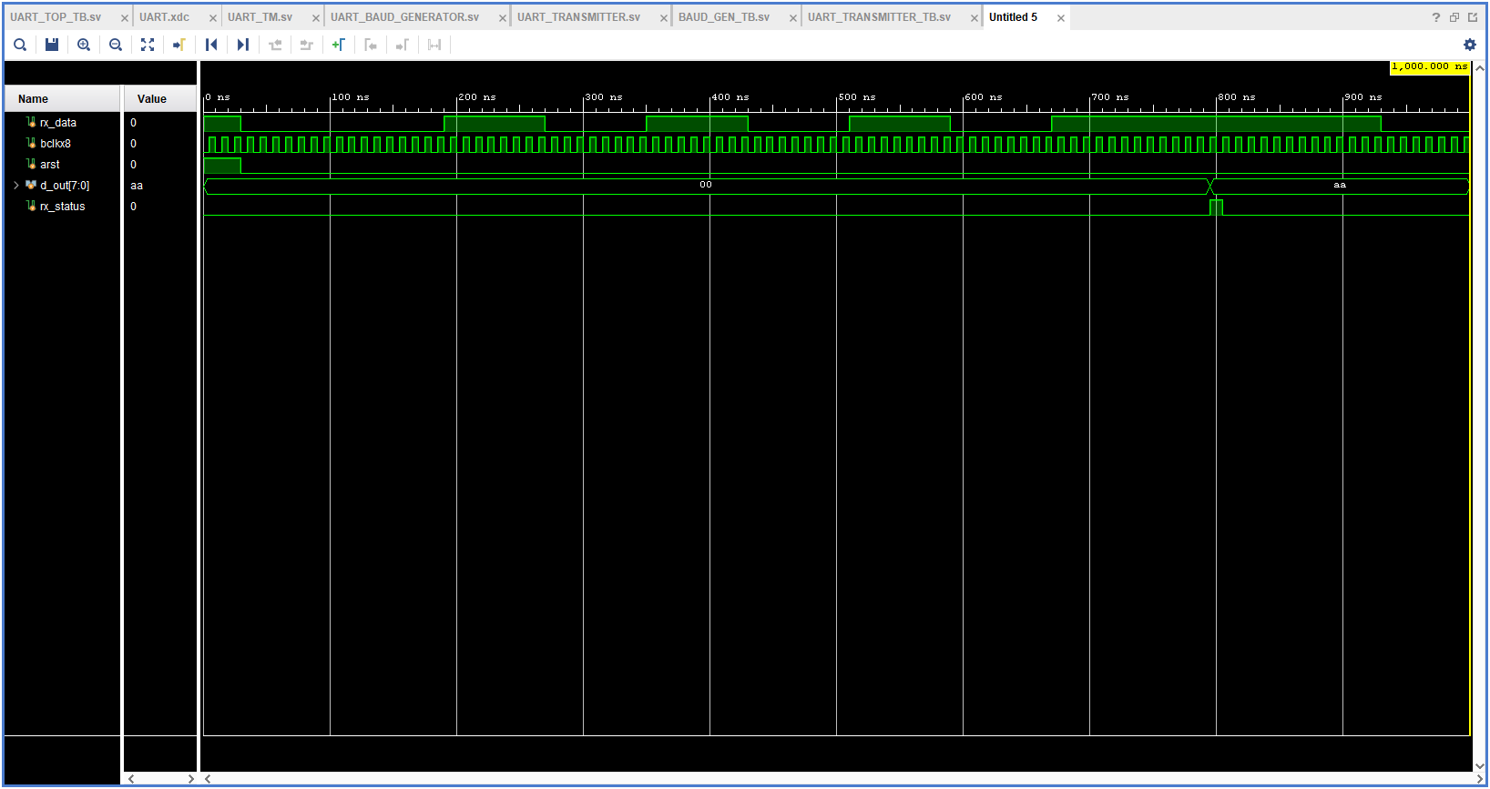
RECEIVER OUTPUT

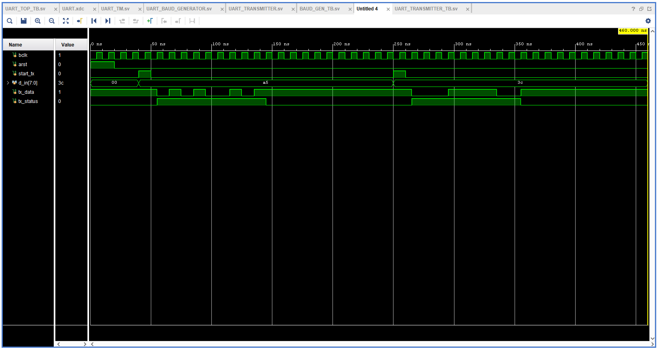
TRANSMITTER OUTPUT
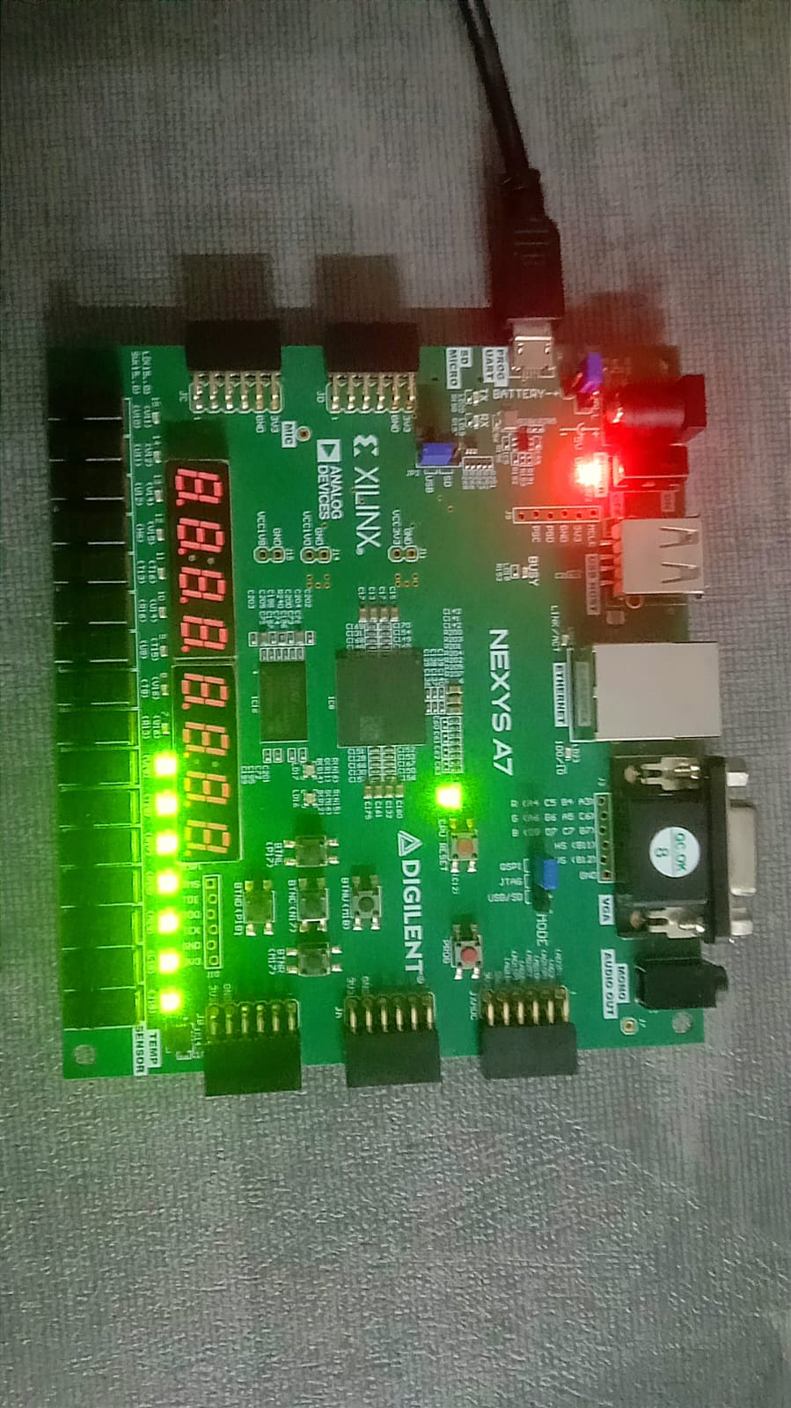
FPGA Prototyping & Verification:
Use Tera Term 5 software to test your UART Transceiver.
- For ASCII value of DELETE

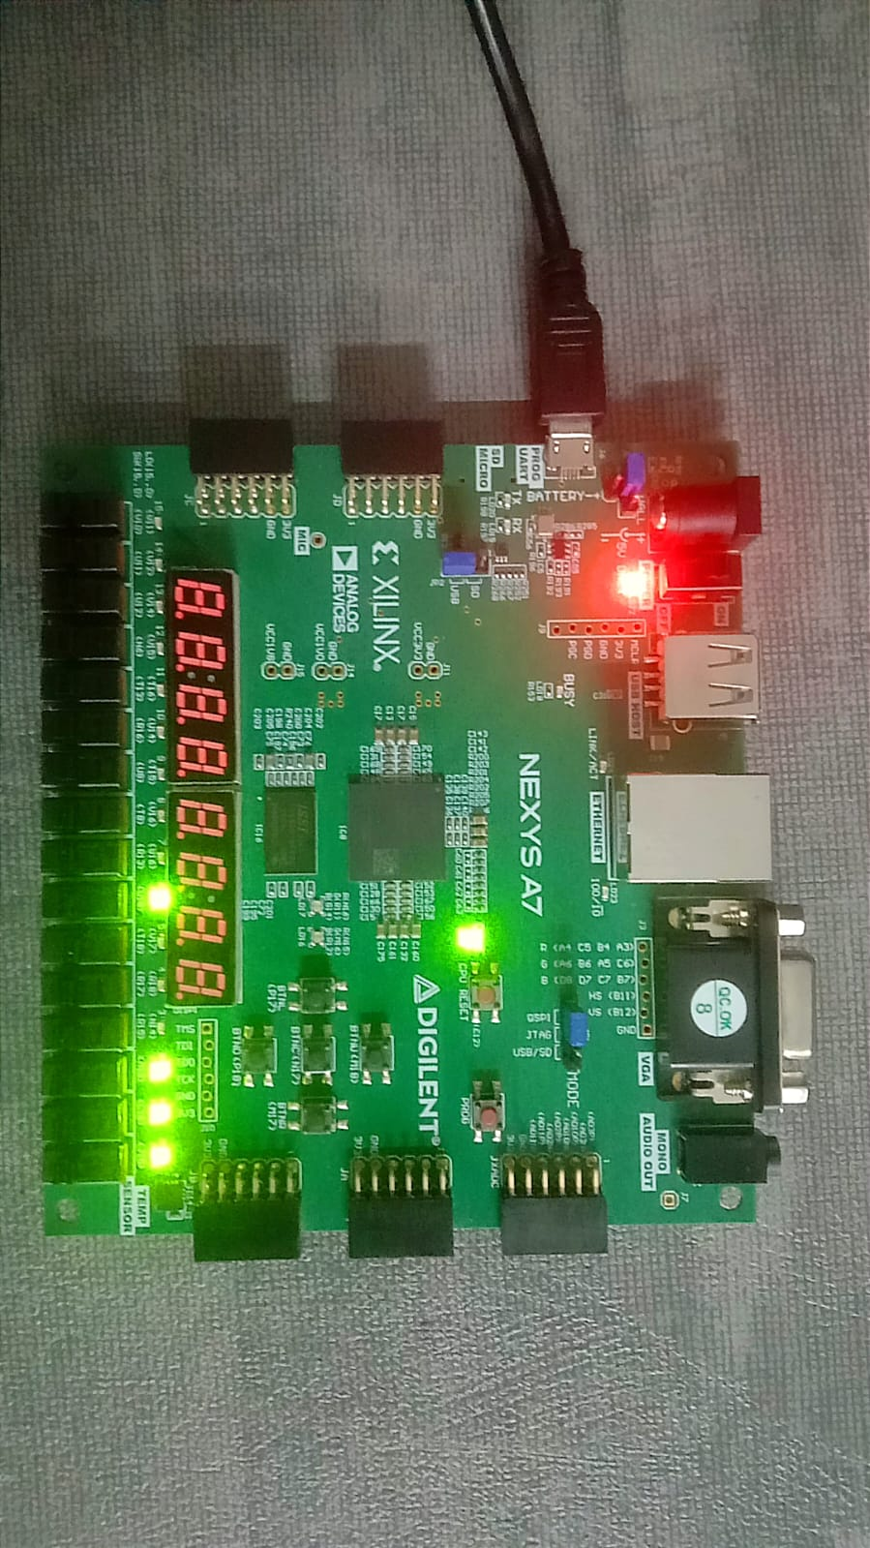
    - For ASCII value of G
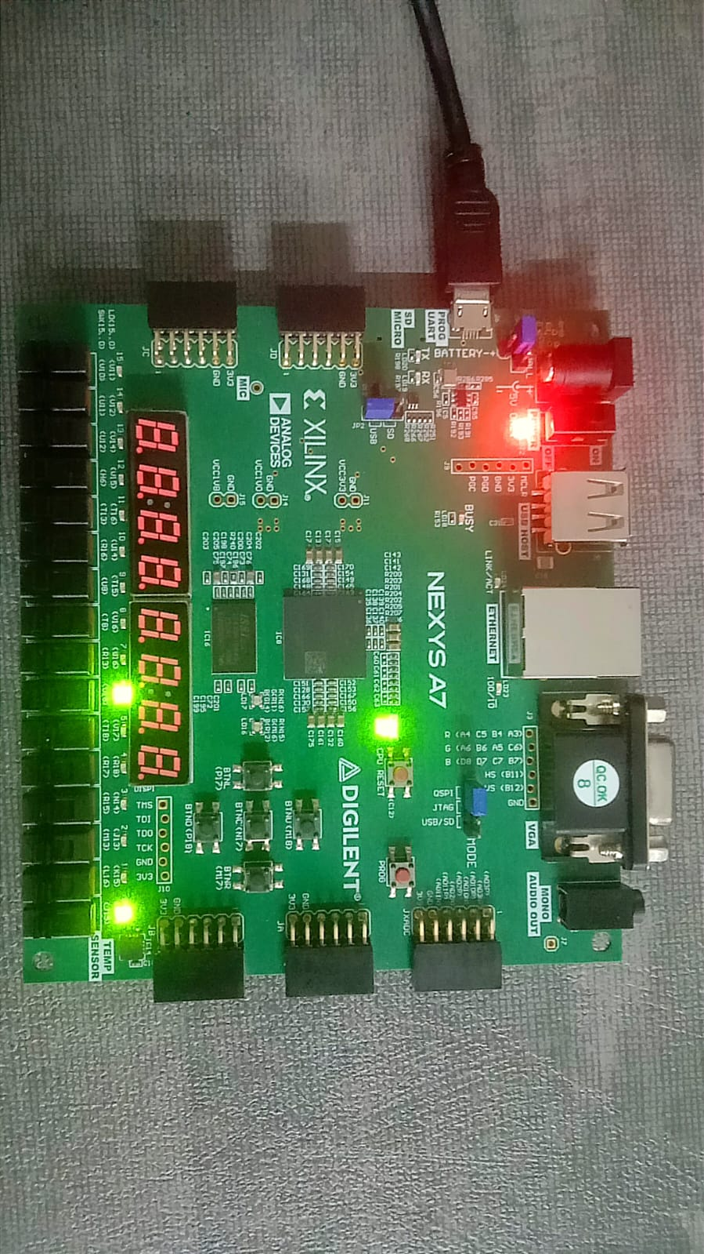

- For ASCII value of A

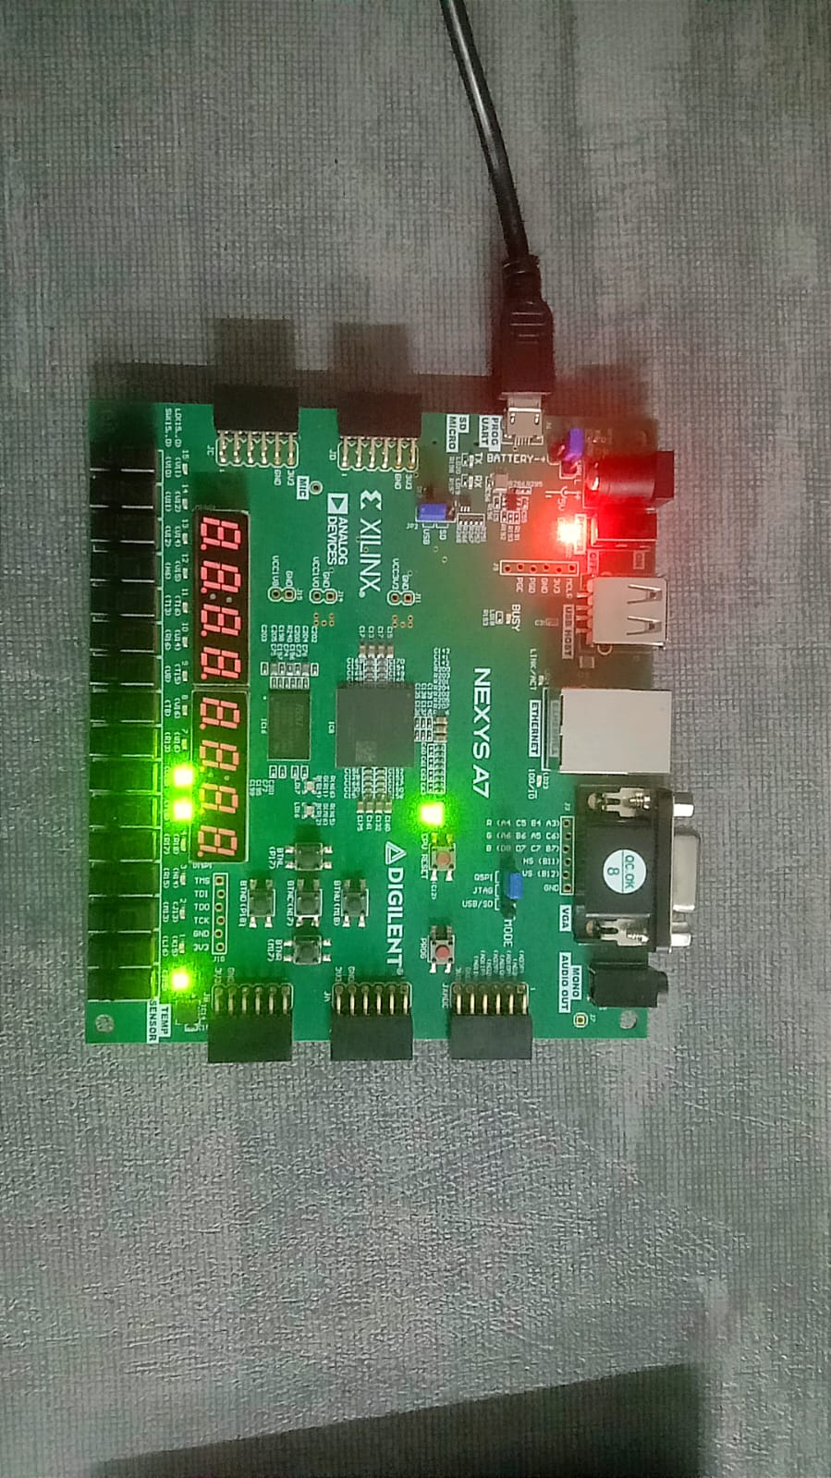
- For ASCII value of a

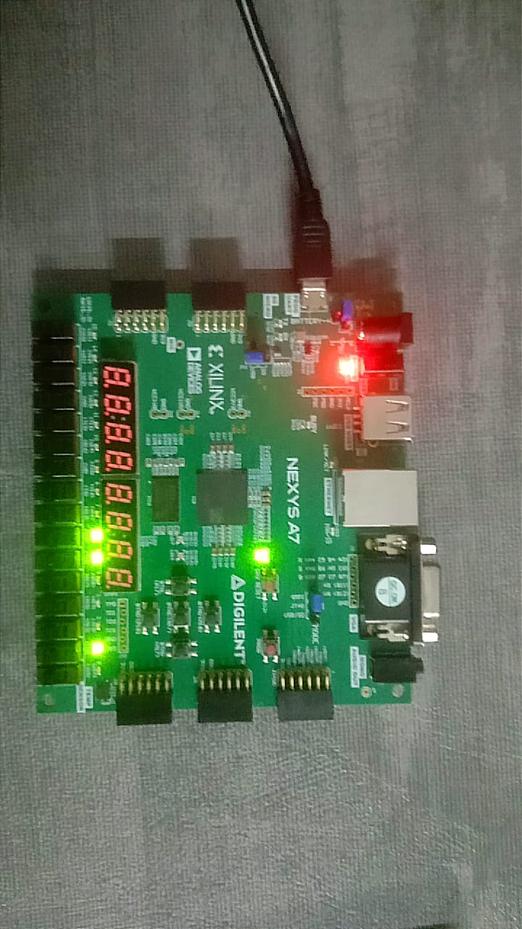
- For ASCII value of b

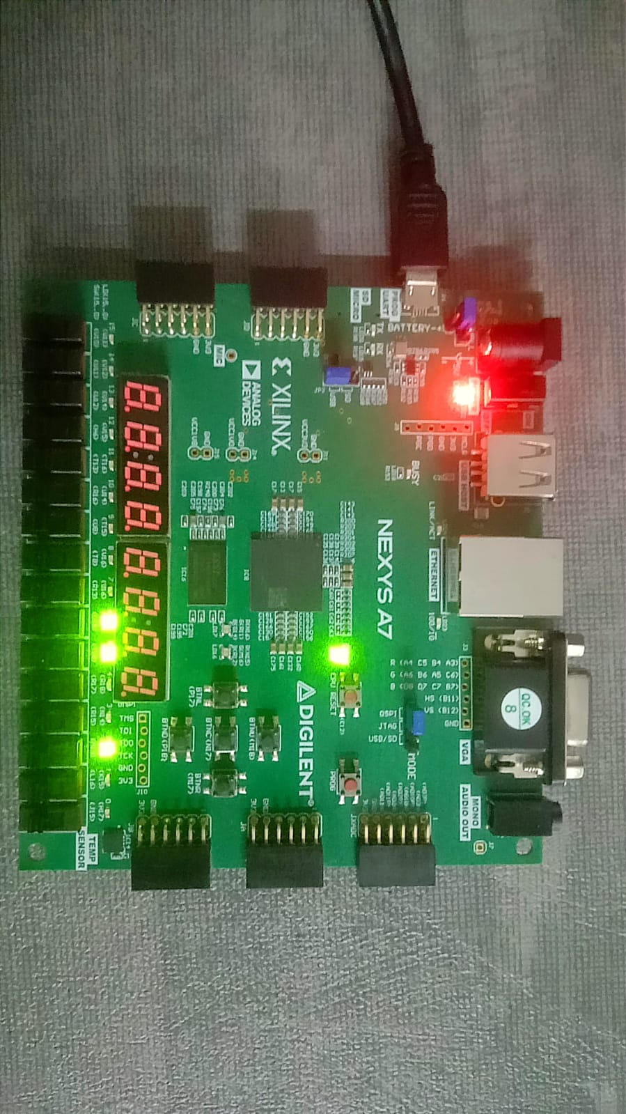
- For ASCII value of d

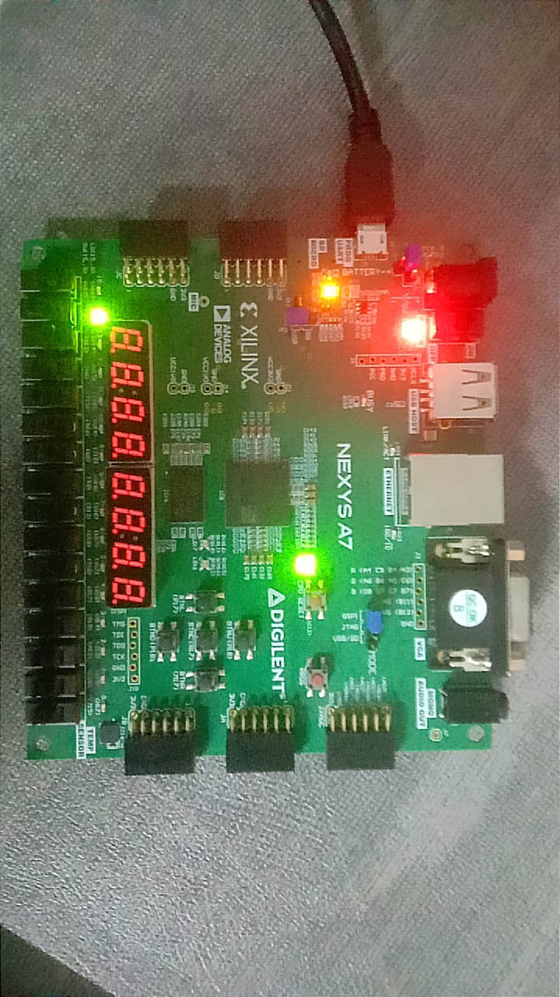
- When we are transmitting date to PC console

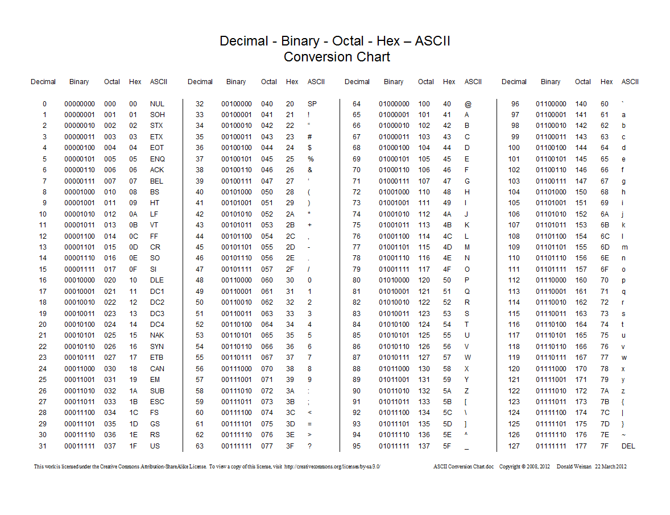
ASCII TABLE

CONCLUSION

- The UART system (transmitter, receiver, and baud rate generator) was successfully implemented and tested on the FPGA.
- The baud rate generator correctly produced the required timing from the 100 MHz clock, ensuring reliable communication.
- The transmitter and receiver operated accurately, performing proper serial-to-parallel and parallel-to-serial data conversion.
- Communication was verified using Tera Term, where correct and error-free data transmission was observed.
- From this lab, I learned UART protocol, FSM design, baud rate calculation, and practical Verilog implementation and debugging on FPGA.

